March 31, 2024 10:00 a.m.

The Church @ Eaton 333 S. Eaton Street
WEST ALAMEDA COMMUNITY Lakewood, Colorado
BAPTIST CHURCH 303-937-3013
www.wacbconline.org

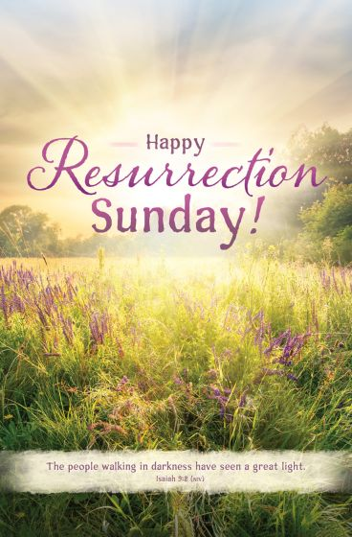

“Living in the Resurrection”

GATHERING – WE OPEN TO GOD’S PRESENCE: “Worship the Lord with gladness; come into His presence with singing.” - Psalm 100:2

Gathering Music

Preparation for Worship
Announcements
Opening Prayer

Easter Greeting

The Prelude & Lighting Our Candles

“Spring” Joy Rollins, piano

Singing Our Call to Worship “He Leadeth Me, O Blessed Thought” v.1

Passing the Peace

PRAISE, A TIME FOR CELEBRATING: “Blessed be Your glorious name, which is exalted above all blessing and praise.” – Nehemiah 9:5b

Opening Hymn of Praise “Christ the Lord Is Risen Today”
Please stand in body or spirit as you wish.

Words of Praise for Easter Resurrection Sunday

Leader: Hallelujah! CHRIST is risen!
People: HE IS RISEN INDEED, HALLELUJAH!
Leader: O Lord, bring new life out of all our struggles and hurts, and create us ever new and fresh
People: a springtime people with Easter in our eyes.
Leader: Lord, let us feel Your Resurrection Life in our pulses and in our breathing. Convince us in our very bodies that we live and die
People: in Your eternal love.
Leader: Release now those mute longings hidden in our hearts so we can join in the early morning Easter song
People: singing of green beginnings and multi-colored hope!
Leader: For Your Song of Life is shaping us into a springtime people
People: with Easter in our eyes!
ALL: HALLELUJAH!

First Gospel Reading John 20:1-18

PRAYER, A TIME OF DRAWING ON SPIRITUAL STRENGTH: “The Lord has heard my supplication; the Lord accepts my prayer.” – Psalm 6:9

Sharing Our Joys and Concerns

Singing Our Call to Prayer “Take Time to Be Holy” v.1
Silent Prayer Pastoral Prayer Lord’s Prayer

STEWARDSHIP, A TIME TO CELEBRATE GIVING AND RECEIVING: “With a freewill offering I will sacrifice to you; I will give thanks to your name, O Lord, for it is good.” – Psalm 54:6
Prayer of Thanksgiving
Offertory “La Fille aux Cheveux de Lin” Joy Rollins, Pianist
Doxology “Praise God from Whom All Blessings Flow”

HEARING, A TIME OF OPENING OURSELVES TO THE LIVING WORD “Draw near, and hear the words of the Lord your God.” – Joshua 3:9b
Hymn of Preparation “Christ Is Alive”

Listening to the Word in Scripture Mark 16:1-8

Listening to the Word Interpreted Pastor Sara Robb-Scott

“Living in the Resurrection”

HYMN OF RESPONSE “Rejoice, the Lord Is King”

THE BENEDICTION

HYMN OF SENDING “Go Now in Peace” v.3

POSTLUDE Joy Rollins, piano

REFLECTIONS
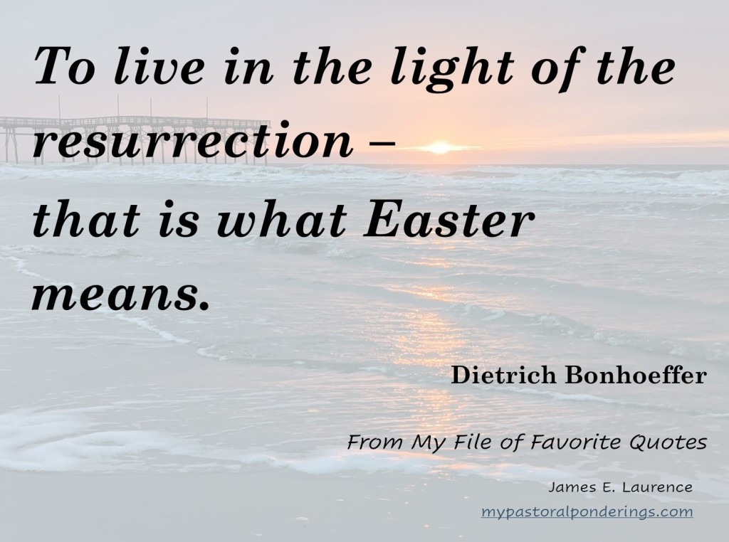
“To go through a "valley of the shadow of death," and emerge on the other side, is to have lived the message of Easter. To be "wounded" and "healed" is to have had a direct experience of "the cross" and the "resurrection." To undergo the pain of loss, and the discovery of new life, is to know the death, burial and transformation that is Easter.” -- Anonymous

Our Lord has written the promise of resurrection, not in books alone, but in every leaf in springtime.
-- Martin Luther

Announcements

Today is Easter/Resurrection Sunday. Join us for a joyous worship celebration of the Resurrection at 10:00 a.m., followed by a Fellowship Brunch at 11:00 a.m.

Talkback resumes next week with a curriculum called Formations, a Bible study focused on spiritual formation.

Bible Study continues on Mondays at 3:00 p.m. in the Fireside Room. We will resume our study curriculum from the Nurturing Faith Journal. No prior Bible study and/or knowledge is necessary. Just come, ready to learn and share!

Upcoming Dates

Sunday, March 31st, 10:00 a.m.: Easter Service and Fellowship Brunch
Mondays at 10:30 a.m.: Spill the Tea, Fireside Room
Mondays at 3:00 p.m.: Bible Study, Fireside Room
Sundays at 10:00 a.m.: Worship Service in the Centrum
Sundays at 11:00 a.m.: Talkback Adult Class in the Fireside Room

We are followers, disciples of Jesus Christ, who will transform the world!

